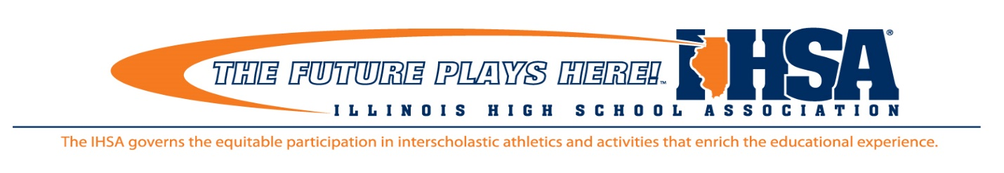

**Hotel Options for the 2025 IHSA Drama State Finals**

In partnership with Visit Chicago Southland* and the City of Oak Lawn, we have been able to negotiate some competitive rates for IHSA schools visiting the area for the State Drama weekend. When making your reservation **contact the hotel directly** and identify yourself as an IHSA competing school for State Drama.

1. [**Double Tree by Hilton Hotel Chicago – Alsip**](https://www.hilton.com/en/attend-my-event/ihsa2025dramastatefinal/)**\* $139**

**5000 West 127th Street, Alsip IL 60803**

**708-371-7300**

1. **Baymont/Alsip* $109-$114**

**12801 S. Cicero Ave. Alsip, IL 60803**

**708-597-3900**

1. **Hampton Inn/Bridgeview* $134**

**7010 S. Harlem Ave. Bridgeview IL, 60455**

**224-513-0017**

1. **Hilton Oak Lawn $149**

**9333 S Cicero Ave, Oak Lawn, IL 60453**

[**(708) 425-7800**](https://www.google.com/search?q=hilton+ak+lawn&rlz=1C1GCEU_enUS1144US1144&oq=hilton+ak+lawn&gs_lcrp=EgZjaHJvbWUyBggAEEUYOTIYCAEQLhgNGK8BGMcBGIAEGJgFGJkFGJ4FMgkIAhAAGA0YgAQyCQgDEAAYDRiABDIJCAQQABgNGIAEMgkIBRAAGA0YgAQyCAgGEAAYDRgeMggIBxAAGA0YHjIICAgQABgWGB7SAQkzNDIzajBqMTWoAgmwAgHxBXXdfr6LHnLg&sourceid=chrome&ie=UTF-8)

For additional information or questions contact:

[**Visit Chicago Southland**](https://www.visitchicagosouthland.com/grouptours?gad_source=1&gclid=CjwKCAiAt4C-BhBcEiwA8Kp0CQZ58fFrNpgvf2StvDw6RJ5L-go1vshrrt0riIi4LmlmJoGEI1GmSRoCOAQQAvD_BwE)

19900 Governors Drive – Suite 200

Olympia Fields, IL 60461

Phone:   708-895-8200 Ext. 105 | Toll Free: 888-895-8233 |  Fax: 708-895-8288

   |  [**www.VisitChicagoSouthland.com**](http://www.visitchicagosouthland.com/)

*“The Official Destination Marketing Agency for Chicago’s South and Southwest Suburbs”*

2715 McGraw Drive ⦁ Bloomington, Illinois 61704

Phone: 309-663-6377 ⦁ Fax: 309-663-7479 ⦁ general@ihsa.org ⦁ www.ihsa.org

2715 McGraw Drive ⦁ Bloomington, Illinois 61704

Phone: 309-663-6377 ⦁ Fax: 309-663-7479 ⦁ general@ihsa.org ⦁ www.ihsa.org